Day 34 - 04th Sept 2025
Id- hrajranj

Task 01:
Create a java program to retrieve dynamodb ttable records and display..
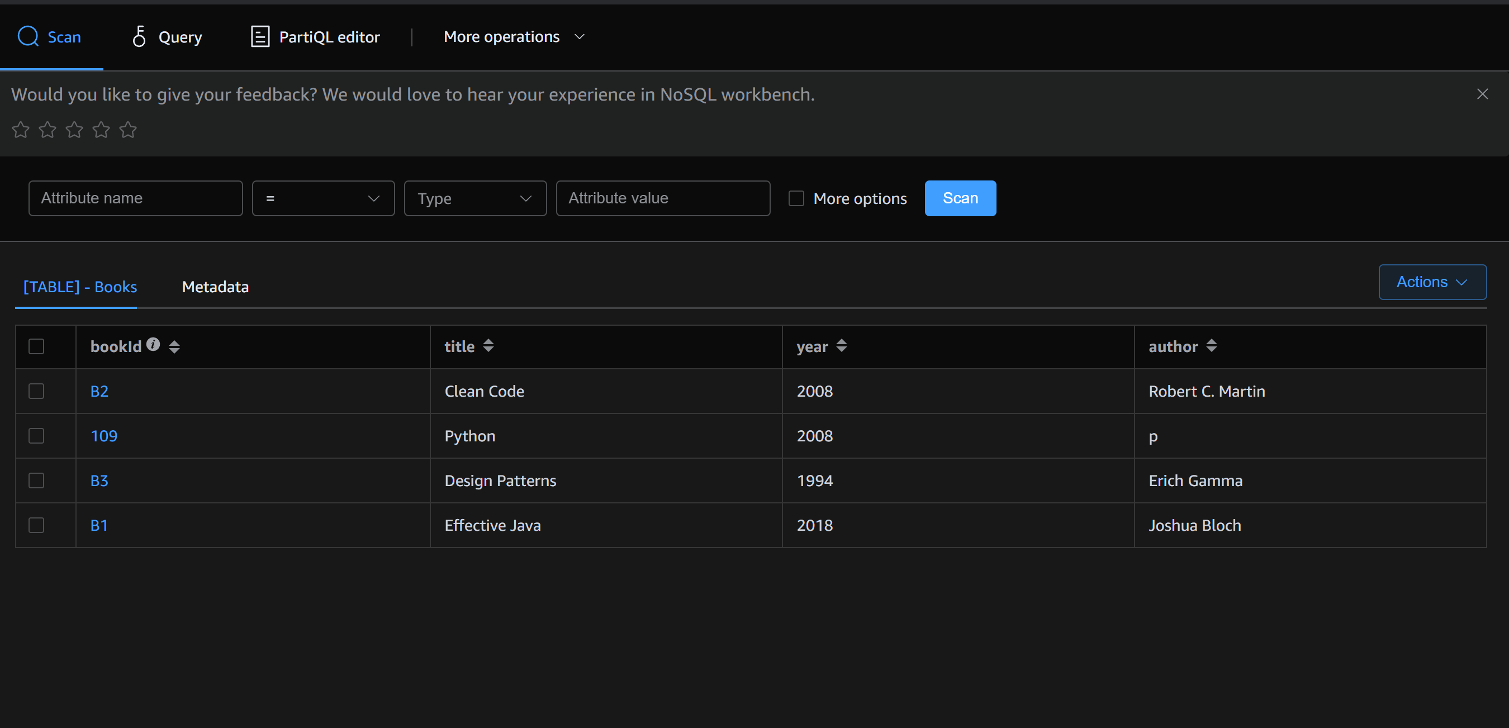

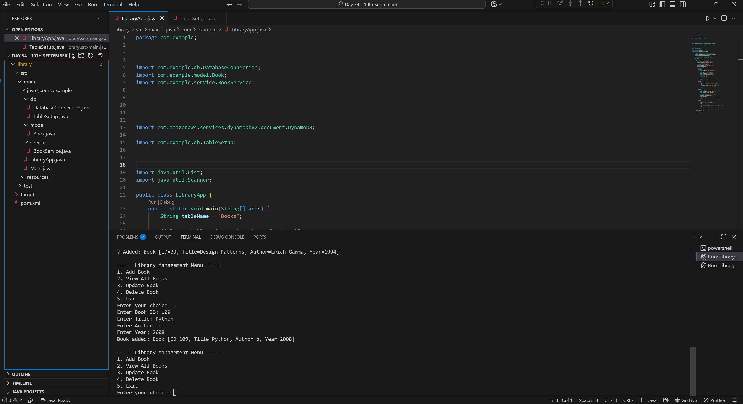

TASK 02:
Create a java program to create a table and insert 2 items .. the NOSQl workbench we should be able to see the table updated
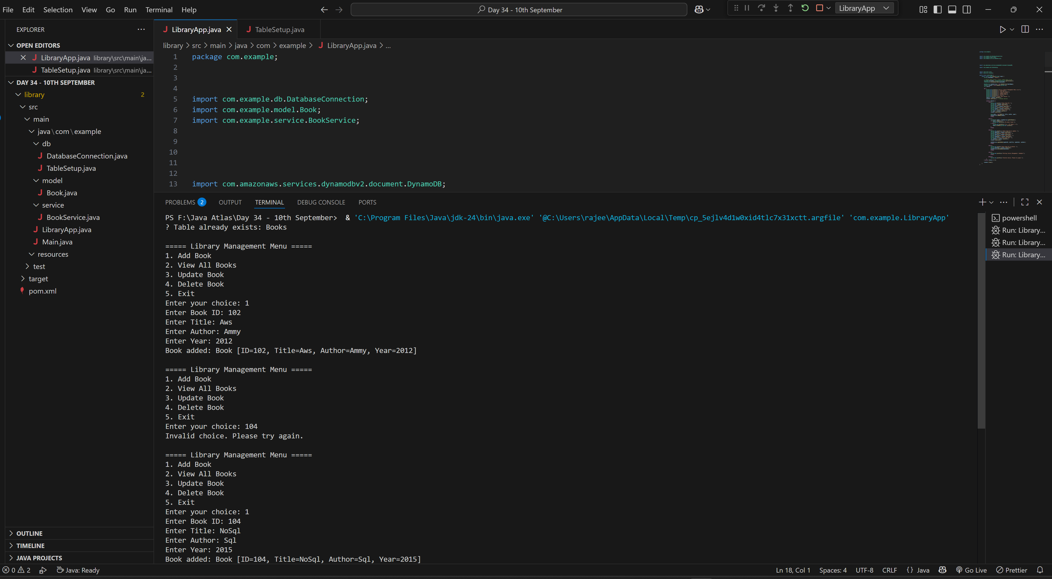

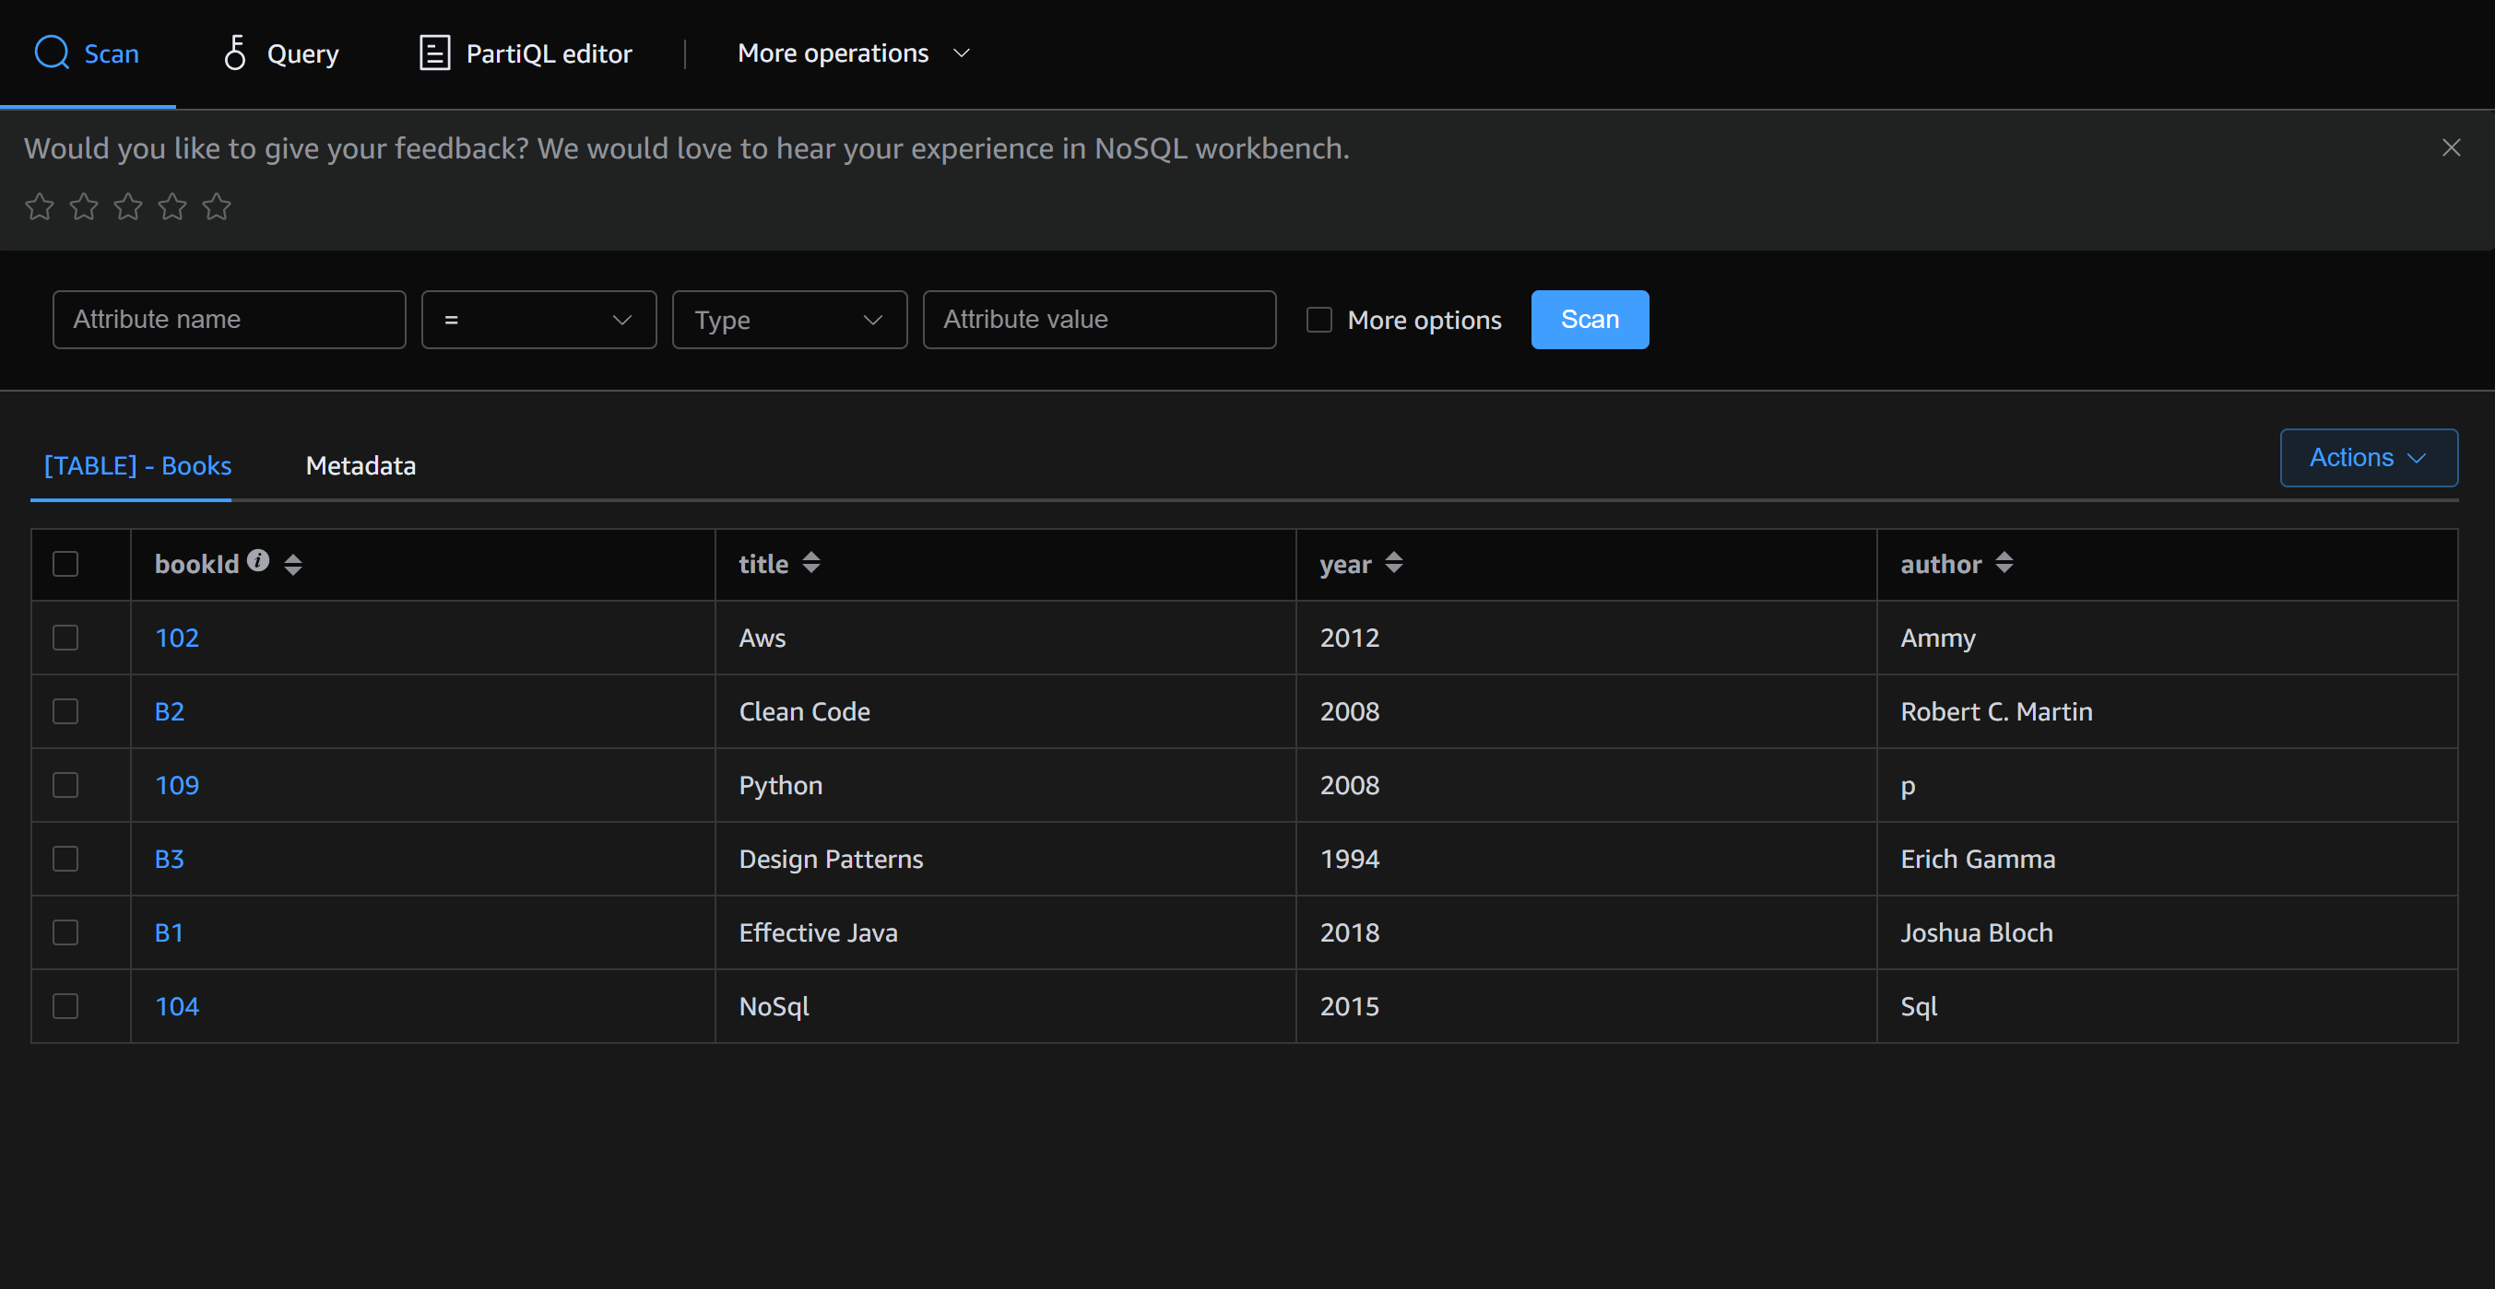

Task 03:
What key features of DynamoDB?
Ans: Key Features of Amazon DynamoDB
- Fully Managed
  - AWS handles infrastructure, patching, scaling, replication, backups.
  - No servers to manage.
- NoSQL (Key-Value & Document Store)
  - Stores data as items (rows) with flexible attributes (JSON-like).
  - Supports key-value lookups and document-style storage.
- High Performance (Single-Digit Millisecond Latency)
  - Designed for low-latency, high-throughput workloads.
  - Supports millions of requests per second.
- Scalability
  - Auto Scaling adjusts read/write capacity based on demand.
  - Supports on-demand capacity mode (pay-per-request).
- Global Tables (Multi-Region Replication)
  - Data automatically replicated across multiple AWS regions.
  - Enables multi-region, multi-master database.
- Flexible Data Model
  - Tables → Items → Attributes (schemaless).
  - Each item can have different attributes.
- Primary Keys & Indexes
  - Partition key (hash key) or Composite key (partition + sort key).
  - Secondary Indexes (GSI, LSI) allow advanced queries.
- Query & Scan
  - Query: Fast lookup by primary key (efficient).
  - Scan: Reads the whole table (slower, costly).
- Consistency Models
  - Eventually Consistent Reads (faster, default).
  - Strongly Consistent Reads (always latest data).
- Durability & Availability
  - Data replicated across multiple AZs in a region.
  - Fault-tolerant & highly available.
- Security
  - Integration with IAM (fine-grained access control).
  - Encryption at rest (KMS) and in transit (TLS).
- Streams & Event-Driven
  - DynamoDB Streams capture real-time changes.
  - Integrates with AWS Lambda → event-driven apps.
- TTL (Time to Live)
  - Automatic expiry & deletion of old/unused items.
- Backup & Restore
  - On-demand backups, Point-in-Time Recovery (PITR) for last 35 days.
- Cost Models
  - Provisioned Mode (set RCU/WCU).
  - On-Demand Mode (pay-per-request).

Task 04:
What are the advantages and disadvantages of DynamoDB?
Ans: Advantages of DynamoDB
- Fully Managed
  - No need to manage servers, patching, replication, or scaling. AWS does it.
- Scalability
  - Supports massive workloads (millions of requests/sec).
  - Auto scaling (or on-demand) adapts to traffic without downtime.
- Low Latency
  - Single-digit millisecond response times, suitable for real-time apps.
- Flexible Schema (NoSQL)
  - Each item can have different attributes.
  - Easy to evolve schema over time without migrations.
- Global Availability
  - Global Tables replicate data across multiple regions automatically.
  - Enables multi-region, multi-master architectures.
- High Availability & Durability
  - Data automatically replicated across multiple AZs.
  - Fault tolerant, durable by design.
- Indexes for Querying
  - Supports Global Secondary Indexes (GSI) and Local Secondary Indexes (LSI) for flexible queries.
- Event-Driven Integration
  - DynamoDB Streams + Lambda = real-time triggers (e.g., notifications, analytics).
- Security
  - IAM for fine-grained access.
  - Encryption at rest (KMS) and in transit (TLS).
- Extra Features
- TTL for automatic item expiry.
- Point-in-Time Recovery (PITR) for backup/restore.

❌ Disadvantages of DynamoDB
- Complex Query Limitations
  - No joins, foreign keys, or complex transactions like SQL databases.
  - Queries must be designed around primary keys & indexes.
- Data Modeling is Hard
  - Requires careful design upfront (choosing partition keys, indexes).
  - Bad design → hot partitions & performance issues.
- Cost Can Be High
  - Expensive if not optimized (especially with Scan operations).
  - Provisioned capacity may lead to over/under-provisioning.
- Limited Query Flexibility
  - Cannot filter or sort across the entire dataset without indexes.
  - Scan is slow and costly for large tables.
- Learning Curve
  - Requires a different mindset compared to RDBMS (denormalization, key design).
- Size & Item Limits
  - Max item size = 400 KB.
  - Not suitable for large binary blobs (use S3 instead).
- Transactions are Limited
  - DynamoDB supports transactions (since 2018), but they’re slower and costlier.

Task 05:
Where do we use DynamoDB (use cases of DynamoDB)
Ans: Use Cases of DynamoDB
1. E-commerce Applications
- Store product catalogs, prices, inventory, user carts, and orders.
- Needs to handle millions of concurrent users during peak sales.
- Example: Amazon.com itself uses DynamoDB for shopping cart management.

2. Gaming 🎮
- Real-time player profiles, game state, scores, and leaderboards.
- Needs millisecond latency to ensure smooth gameplay.
- Example: Storing multiplayer match history and progress.

3. IoT (Internet of Things) 🌐
- Store data from millions of connected devices and sensors.
- Example: Smart home devices storing telemetry data in DynamoDB.

4. Social Media & Messaging Apps
- User profiles, follower lists, chat messages, media metadata.
- Needs high availability & real-time updates.
- Example: Chat apps using DynamoDB Streams + Lambda for instant notifications.

5. Mobile & Web Applications 📱
- Used as a backend database with AWS AppSync (GraphQL) or API Gateway.
- Supports offline sync and real-time updates.
- Example: News apps, food delivery apps storing user preferences/orders.

6. Financial Services 💰
- Fraud detection (fast lookups), transaction logs, customer activity.
- DynamoDB Streams + Lambda → real-time monitoring.

7. Content Management & Media Metadata
- Store metadata for videos, images, documents (actual media in S3).
- Example: Streaming platforms storing user watch history & recommendations.

8. Ad Tech & Personalization 📊
- Real-time ad targeting & personalization.
- Stores user sessions, preferences, clickstream data.

9. Healthcare Applications 🏥
- Store patient records, IoT device readings, and prescriptions.
- Must be secure, scalable, and available 24/7.

10. Serverless Applications ⚡
- Works seamlessly with AWS Lambda for event-driven apps.
- Example: An image upload triggers Lambda → DynamoDB → Notify users.

🚀 Real-World Examples
- Amazon.com → Shopping cart service.
- Netflix → Global availability for streaming metadata.
- Zoom → Chat and meeting state management.
- Airbnb → Storing user sessions & search history.

Task 06:
What is DynamoDBMapper?
12.03 to 12.08

Task 07:
What are DynamoDb Projections?
Ans: When we create a secondary index in DynamoDB (either Local Secondary Index - LSI or Global Secondary Index - GSI), you must choose which attributes from the base table will be copied (projected) into the index.
👉 These copied attributes are called a Projection.
They decide what data is available when you query the index (without going back to the main table).

🎯 Types of Projections in DynamoDB
DynamoDB supports 3 types of projections:
- KEYS_ONLY
  - Only the primary key attributes (partition key & sort key) of the table and index are projected.
  - Smallest storage, cheapest option.
  - If you need other attributes → you must fetch them separately from the base table.
✅ Use when: You only need keys to retrieve full items later.

- INCLUDE
  - Projects the index keys + specific non-key attributes you choose.
  - More efficient than fetching from base table if you need only a few attributes.
✅ Use when: You need only a few extra attributes in queries.

- ALL
  - Projects all attributes from the base table into the index.
  - Queries on the index return everything without going back to the base table.
  - Uses more storage & costs more.
✅ Use when: You often need the full item directly from the index.

📝 Example
Suppose you have a Books table:
bookId (PK) | title | author | genre | price
101 | Harry Potter | Rowling | Fantasy | 20
102 | Clean Code | Martin | Tech | 25
Now, you create a GSI on genre.
- KEYS_ONLY → index stores just genre + bookId.
- INCLUDE (title, price) → index stores genre + bookId + title + price.
- ALL → index stores everything (genre, bookId, title, author, price).

✅ Benefits of Projections
- Improve query performance (less fetching from base table).
- Optimize cost (store only what’s needed).
- Reduce latency (fewer round trips).

🔑 In short:
DynamoDB Projections define which attributes from the base table are copied into a secondary index, helping you balance performance, storage, and cost.

Task 08:
How can you say that DYnamoDB prevents data loss?
Ans : DynamoDB is designed for high durability and availability, which is why AWS often markets it as “built-in resilience with no data loss.” Let’s break it down.

🔒 How DynamoDB Prevents Data Loss
1. Multi-AZ Replication (Durability by Default)
- Every item you write to DynamoDB is synchronously replicated across 3 different Availability Zones (AZs) in the same AWS region.
- This means even if one or two AZs fail, your data is safe in the third.

2. High Availability
- DynamoDB’s design guarantees 99.999% (five nines) availability SLA for global tables.
- Continuous replication ensures the service keeps running even in hardware or network failures.

3. Global Tables (Multi-Region Replication) 🌍
- With Global Tables, data is replicated across multiple regions, providing disaster recovery and regional fault tolerance.
- Even if an entire AWS region goes down, your data is available in another.

4. Backups & Point-in-Time Recovery (PITR)
- On-Demand Backups → You can create full backups anytime without affecting performance.
- PITR (Point-in-Time Recovery) → Restores your table to any second within the last 35 days, protecting against accidental deletes/overwrites.

5. Streams for Data Recovery
- DynamoDB Streams capture a time-ordered sequence of item changes (insert, update, delete).
- You can replay these changes using AWS Lambda to recover or replicate data elsewhere.

6. ACID Transactions (Optional)
- DynamoDB supports ACID-compliant transactions across multiple items/tables.
- Prevents partial writes or inconsistent states, reducing logical data loss.

7. Automatic Scaling & Throttling Protection
- Auto-scaling prevents overloads by adjusting capacity.
- If throughput is exceeded, requests are throttled (not dropped), meaning no silent data loss.

8. Security Against Data Corruption
- Encryption at rest (KMS) and in-transit (TLS) ensures data is not tampered with.
- Strong IAM policies prevent unauthorized deletion.

✅ Summary
DynamoDB prevents data loss by:
- Replicating data across 3 AZs (default).
- Optional multi-region replication via Global Tables.
- PITR & backups for accidental data loss.
- Streams & transactions for recovery and consistency.
- Throttling instead of dropping requests under heavy load.

Task 09:
What is in-place atomic updates means ? does dynamoaDB supports?
Ans: In-place atomic update means you can safely modify a specific attribute of an item (like incrementing a counter) without:
- Overwriting the whole item.
- Causing race conditions when multiple updates happen at the same time.
Yes, DynamoDB supports atomic, in-place updates.

Task 10:
What are Streams in DynamoDB?
Ans: DynamoDB Streams is an optional feature that captures a time-ordered sequence of item-level changes (insert, update, delete) in a DynamoDB table.
- Think of it as a real-time change log for your table.
- Each stream record represents one change (with before/after images of the item).
In short: Streams let you react to changes in DynamoDB in real time.

Task 11:
What are DynamoDb Pricing Tiers?
Ans: Amazon DynamoDB pricing is based on several factors, mainly:
- Read/Write capacity (Provisioned or On-Demand)
- Storage
- Additional features (Backups, Streams, Global Tables, etc.)

🔹 1. Capacity Modes (Reads & Writes)
a) Provisioned Capacity Mode
- You specify how many reads (RCUs) and writes (WCUs) per second you need.
- Suitable for predictable workloads.
- You can enable Auto Scaling to adjust capacity.
👉 Pricing:
- 1 WCU = 1 write/second for an item up to 1 KB.
- 1 RCU = 1 strongly consistent read/second for an item up to 4 KB
(eventually consistent = 2 reads).

b) On-Demand Capacity Mode
- Pay-per-request: You don’t set capacity upfront.
- DynamoDB auto-scales instantly.
- Great for unpredictable or spiky workloads.
👉 Pricing:
- You pay per million reads/writes.

🔹 2. Storage Pricing
- You pay for data stored in DynamoDB tables.
- Example: $0.25 per GB-month (region-dependent).

🔹 3. Streams & Triggers
- DynamoDB Streams themselves are free.
- But if you process them with AWS Lambda, you pay for Lambda executions.

🔹 4. Backups & Restore
- On-Demand Backup → Charged per GB of data backed up.
- Point-in-Time Recovery (PITR) → Small hourly charge + per GB restore cost.

🔹 5. Global Tables (Multi-Region Replication)
- You pay for replicated reads/writes in each region.
- Example: If you write 1 KB to a global table with 3 regions, you pay for 3 writes.

🔹 6. Data Transfer Costs
- Data transfer within a region = free.
- Data transfer across regions (Global Tables or Streams) = charged.

Task 12:
Do you have any max limit for Item Size in DynamoDb? If so what is it?
Ans: Maximum Item Size = 400 KB (including all attribute names + values + overhead).
- Applies to a single item (row) in a table or index.
- This limit includes:
  - Partition key + sort key
  - Attribute names and values
  - Data types (strings, numbers, binary, etc.)
  - JSON overhead if you store documents
👉 If your data is bigger than 400 KB → you cannot store it in one DynamoDB item.

Task 13:
At a max of how many GSI’s Global Secondary Indexes can you create in a table?
Ans:
Maximum Number of GSIs in DynamoDB
- You can create up to 20 Global Secondary Indexes (GSIs) per table.
- This is the hard service limit as of now.

Other Index Limits (for context)
- Global Secondary Index (GSI) → Max 20 per table.
- Local Secondary Index (LSI) → Max 5 per table (must be defined at table creation).
- Each index has its own RCUs, WCUs, and storage costs.
- Indexes also follow the 400 KB item size limit (projected attributes count too).

Task 14:
What is DynamoDb Accelarator?
Ans:
- DAX = DynamoDB Accelerator.
- It is a fully managed, in-memory cache for DynamoDB.
- Provides microsecond latency (µs) for reads, compared to DynamoDB’s usual millisecond (ms) latency.
- It’s APIs compatible → You don’t need to rewrite queries, just use the DAX client instead of DynamoDB client.

Task 15:
What are DynamoDB Global tables?
Ans:
- Global Tables = multi-region, fully replicated DynamoDB tables.
- They let you replicate your DynamoDB data automatically across multiple AWS Regions.
- Each replica is a full DynamoDB table, and all replicas are kept in sync using streams + replication.
- Designed for global applications that need low-latency access from different regions.
- In short: A single table replicated across the world with multi-master writes.

Task 16:
What are indexes and Secondary indexes in DynamoDB?
Ans:
- An index in DynamoDB is like an alternate view of your data that helps you query faster and more flexibly.
- Every index uses a partition key + optional sort key.
- DynamoDB automatically maintains indexes whenever you insert, update, or delete items in the base table.
👉 Think of it like extra search paths to your data, beyond the main table’s primary key.

📌 Types of Indexes in DynamoDB
1. Primary Index (defined at table creation)
- Every table has a primary key = partition key (or partition + sort key).
- This is the default way to access items.
- Example: Users table with UserId as the primary key.

2. Secondary Indexes (additional indexes you can define)
🔹 (a) Local Secondary Index (LSI)
- Defined at table creation only (cannot add later).
- Shares the same partition key as the table but allows a different sort key.
- Lets you query the same partition data in different ways.
👉 Example:
- Base table: Orders with CustomerId (PK) and OrderId (SK).
- LSI: CustomerId (PK) and OrderDate (SK) → lets you query orders by date for the same customer.
📌 Limit: Max 5 LSIs per table.

🔹 (b) Global Secondary Index (GSI)
- Can be created anytime (not just at table creation).
- Has its own partition key and optional sort key (different from the base table).
- Lets you query data using completely different attributes.
👉 Example:
- Base table: Users with UserId (PK).
- GSI: Email (PK) → lets you query users by email address.
📌 Limit: Max 20 GSIs per table.

Task 17:
What are Hot Keys and Hot Partitions?
Ans:
Hot Key
- A Hot Key happens when one specific partition key is accessed too frequently compared to others.
- This causes uneven traffic because DynamoDB spreads data across partitions.
- If too many reads/writes go to the same key → that partition becomes overloaded.
👉 Example:
- Table: Orders with CustomerId as partition key.
- If one VIP customer (CustomerId = 12345) has millions of orders and gets hit with lots of queries → that key becomes "hot".
Hot Partition
- A Hot Partition is when one partition (storage unit) in DynamoDB is receiving a disproportionate amount of traffic.
- This usually happens because of hot keys or poor partition key design.
- DynamoDB partitions have throughput limits → if one partition gets overloaded, queries slow down or get throttled.
👉 Example:
- Partition key = Country.
- If all your users are from "India" but few from other countries → DynamoDB stores all "India" data in one partition → hot partition problem.

Task 18:
What are Table level operations and Item level operations in DynamoDB?
Ans:
1. Table-Level Operations
These operations apply to the entire table or index (not just one item).
🔹 Examples:
- CreateTable → Create a new DynamoDB table.
- DeleteTable → Delete a table and all its items.
- UpdateTable → Modify table settings (capacity, indexes, TTL, etc.).
- DescribeTable → Get metadata (status, key schema, throughput, indexes).
- ListTables → List all tables in your AWS account/region.
👉 Use Case: Administrative tasks like creating, scaling, or deleting tables.

📌 2. Item-Level Operations
These operations deal with individual items (rows) inside a table.dd
🔹 Examples:
- PutItem → Insert a new item or overwrite an existing one.
- GetItem → Retrieve a single item by primary key.
- UpdateItem → Modify attributes of an existing item.
- DeleteItem → Remove a single item by primary key.
- BatchWriteItem → Insert or delete multiple items in bulk.
- BatchGetItem → Retrieve multiple items in one request.
👉 Use Case: Day-to-day CRUD operations on specific data records.

📌 Quick Comparison
Operation Type | Scope | Examples | When to Use
Table-level | Entire table or index | CreateTable, DeleteTable, UpdateTable, DescribeTable | For table setup, scaling, and management
Item-level | Individual item (row) | PutItem, GetItem, UpdateItem, DeleteItem | For CRUD operations on data

✅ Summary:
- Table-level ops → manage tables as a whole.
- Item-level ops → work with specific items inside a table.

